**Sheets 1**

PACT => people, activities, context, technologies

- Elements for designing interactive systems: PAC comprise operational demands, T theories

Sit Cog Eng

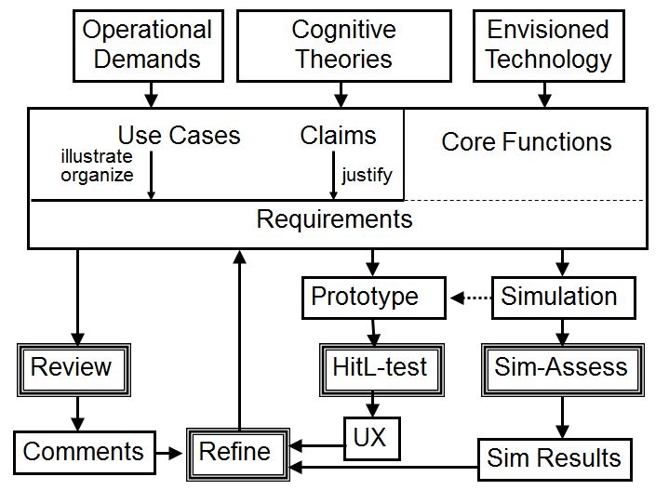

Create Scenarios => stories about people undertaking activities using technologies in contexts

…with personas=> people that are archetypical in the domain; synthesize from knowledge of people in the domain, having goals and being abstract types.

UX design: be mindful of performance & knowledge, judgment & feelings

From gaming => pay attention to identity, adaptivity, narrative, immersion and flow in your system

Classical principles in human-centered design:

Visibility, Consistency, Familiarity, Affordance, Navigation, Control, Feedback, Recovery, Constraints, Flexibility, Style, Conviviality (politeness)

**Sheets 2**

User Experience Engineering is/has:

* Iterative
* Collaborative (multi-disciplinary)
* Usability objectives (does it work and how well)
* Experience objectives (in rare cases, one may want to have fun as well)



Scenarios => reason about situations of use before they are created

Have a setting, actors and a sequence of actions and events, and can be elaborated as prototypes

They are useful for reflection, concrete and flexible, provide multiple views on the interaction, can be abstracted & categorized and provide easy accessibility of design activities (for stakeholders)

We have Problem scenarios (about problem domain) and Design scenarios (a new vision)

Use Cases => scenario is instantiation of use case. Use cases describe complete system functionality, give contextualization and organization of requirements

Requirements => What the system should be able to do. SCE focuses on cognitive requirements

Claims => Justify requirements, highlighting expected outcomes, up- and downsides. They must be concrete and testable.

Task analysis => specify task structure => context => scenarios => (add or refine scenarios) => use cases => requirements => claims analysis => test (SEE PICTURE ABOVE)

Human Factors Knowledge => Time pressure/planning, Resource management/Uncertainty, Situation awareness/Sense making, Collaboration/**Observability**, Interdisciplinary/Non-routine work, Task Load/Emotion, Physical Demanding/Condition, Communication/Culture

Functional module of observability support => explicitly define work processes, workload, and progress towards goal accomplishment

**Sheet 3**



Cognitive task load model => 3d: time occupied, task switches, complexity. Optimum is in the middle, preventing overload and underload

Generate use cases => Have task and event structure. Tasks + Events are action sequences. Action sequences + Situated event sequences give situated use cases.

Case study: Royal Dutch Navy. Evaluation of new task load system: adaptive automation

Good IUXE =>

- Relevant theory in root concept

- Generate use cases from task and even structure

- Human-in-the-loop evaluation for criteria, refining specifications and testing the general effect.

**Sheet 7**

Self-manager=> keep track of own health, etc etc. to improve the quality of life

Self-management affected by personal profile, characteristics and the like.

Variation between characteristics grows stronger with age (both younger and older vary more)

Different types of people in trials: only first glimpse, early/late dropouts and maintainers.

These self-management systems need to persuade people to keep using them

E-partners may help to motivate such

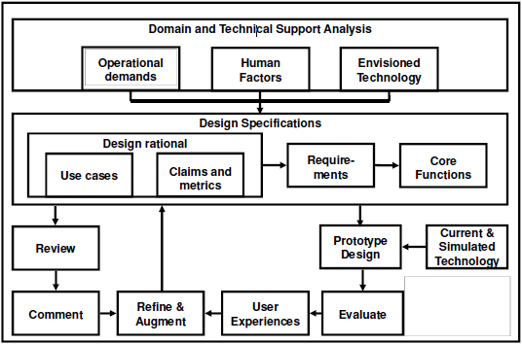

Take a look at the use case if you’re interested

Personal approach seems to have better results when using affective robots

**Sheets 9**



Situation awareness: *perception* of elements, *comprehension* of their meaning and *projection* of their status in the near future

Team SA => degree to which team members possess the SA required for their responsibilities

Shared SA => degree to which team members possess same SA on shared requirements

Eight demons of SA

* Attentional tunneling -> focus on specific parts too much
* Requisite memory tap-> too much info to remember and apply to real world
* Workload/Anxiety/Fatigue/Other stressors -> reduce info capacity, increase potential for tunneling
* Data overload -> lots of data, finding specifics or a very dynamic environment
* Misplaced salience -> salience draws attention, but misuses can be misleading, distractive and/or overwhelming
* Complexity creep -> complex systems hard to understand
* Errant mental models -> most dangerous being mode error; thinking the system is in another mode than it actually is
* Out-of-the-loop syndrome -> with automation, lower involvement for people. Decreases attention and increases chance for bad decision making when things do go wrong

Evaluation of SA: can be objective or subjective, real time or post-test. A distinction exists between performance and behavioral measures

Virtual environments: more controllable, easy to log and repeat many times, inexpensive

Realistic is not always possible and more risky.

SAGAT: situation awareness global assessment technique

See case studies

Support SA =>

* Address three levels (perception, comprehension, projection)
* Take the demons into account
* Address team and shared SA
* Test (with virtual environments)

**Sheets 13**

On the values of technology

Values that play a role are (for example) : privacy, trust, sustainability (blergh), wellbeing, autonomy etc. etc.

Algorithmic filtering of google and facebook. Good?

Same for making (important) medical decisions based on data processed with a computer

“Do you want more false positives or false negatives?”

In technology: computer ethics (technology’s impact on human lives) and social informatics (study design, use and consequence of IT)

Value implication => Embodied (force behavior by design), exogenous (society determines form), interactional (design based on users)

Key concepts:

stakeholders (direct, indirect, roles)

values (designer, stakeholder and explicitly supported values)

Methodological steps => tripartite iterative/integrative methodology

Conceptual, Empirical and technical investigation

Conceptual investigations => Identification of stakeholders, potential harms/benefits and values.

Empirical investigations => stakeholders’ views and values

Technical investigations => support/hinder of human values by existing techs

Other VSD aspects

Multi-lifespan (long-term thinking, sustainability {blergh})

Pervasiveness (widespread adoption, geographic/cultural/demographic factors)

Read cases for clarity

Other VSD-like things:

Worth-focused design  
Values in design  
Values at play

**Paper 1**

SCE for crew support in space

REQUIRED: usability, cognitive support. SOLUTION => ePartners

On cognitive engineering  
CE is iterative, collaborative and has incrementally developed support functions

Usability framework has four objectives: effectiveness, efficiency, user satisfaction and learnability